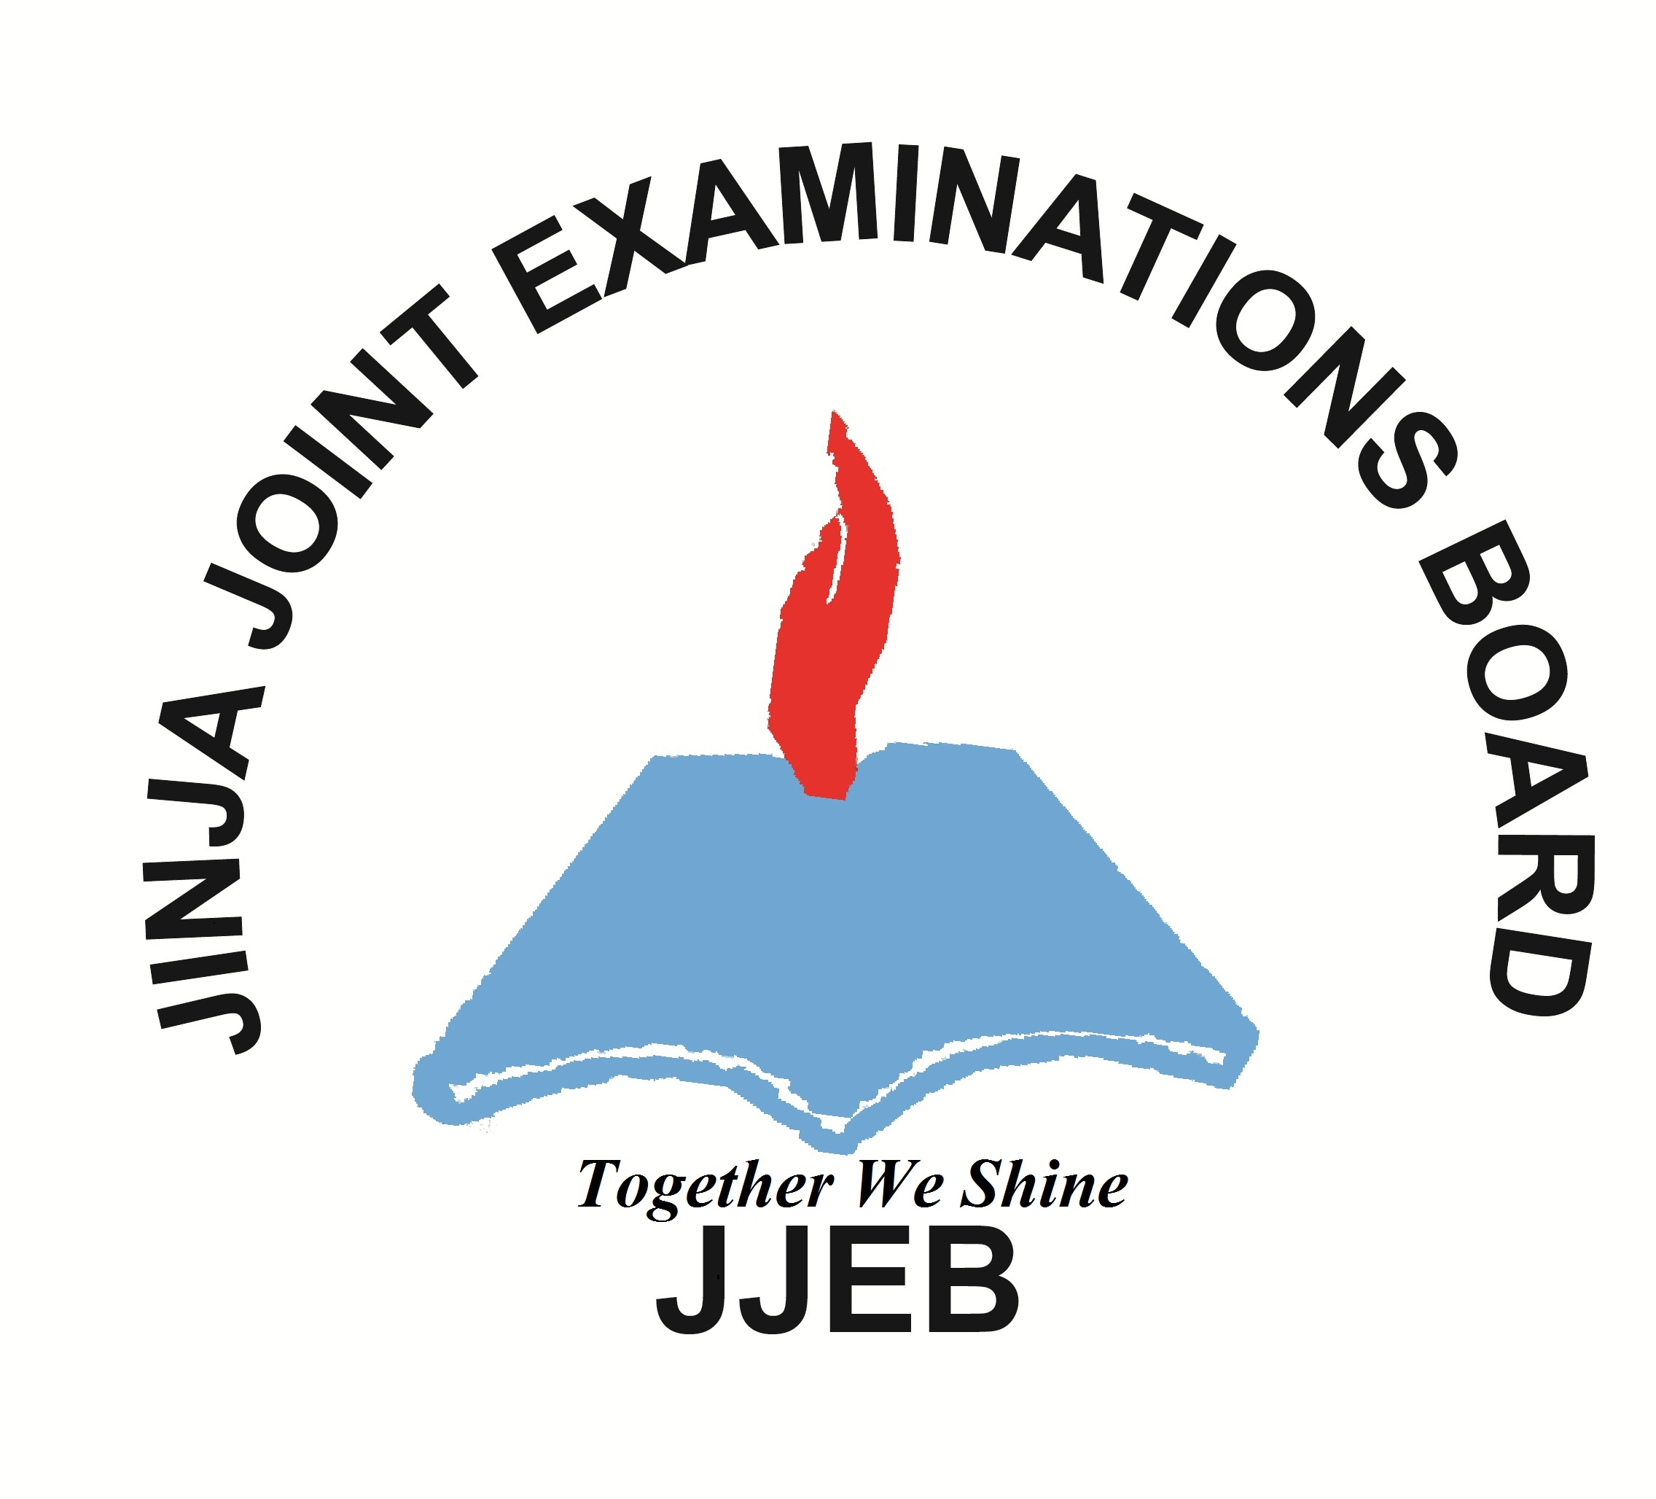
612/6 Inst.
IPS ART
(CRAFT A)
Paper 6
AUGUST, 2017
$$5\frac{1}{4}\text{hours}$$

JINJA JOINT EXAMINATIONS BOARD

Uganda Certificate of Education
MOCK EXAMINATIONS – AUGUST, 2017
IPS ART
CRAFTS B
Paper 6
5 hours 15 minutes
Planning Session : 2 hours 15 minutes
Practical : 3 hours

INSTRUCTIONS
ANSWER ONE question, Stating its Topic.
Drawing instruments and similar aids are allowed.
Demarcate an area of 5cm x 12 cm in the top right-hand corner of the front surface of the paper
In it write clearly your name, centre number and index number in that order. This area must not be painted.
A part from the particular media asked for by the question, candidates are recommended to consider the choice of different materials and process. The following are possible: coloured inks, poster and water colours, stencils, wax resist, collage, or printing from lino, potato and vegetable or fruit or the use of any material such as junk wire or string which may give an interesting pattern.

INSTRUCTIONS TO CANDIDATES FOR THE PLANNING SESSION (2 hours)
You are required to spend the 2 hours 15 minutes doing the following:-
- Organizing tools and materials.
- Sketching/development of sketches
- Transfer if necessary
On no account may you take out of the examination room a copy of the tests or your plans/sketches and you MUST NOT bring in any other notes/sketches or any such specimen into the examination room on returning for the practical session.
Your notes/sketches must bear your index number and number of task you have selected.
All these should be handed to the supervisors at the end of the practical test.

SECTION A
- Make a flower pot using a coil method, develop your ideas from any natural object and show development sketches. The pot should be about 14cm wide by 20cm high.

- Make a paper machie mask for a five year old child. The composition should depict any form of humorous exaggeration such as cartoons. The size should be suitable for the human face

SECTION B;
- Develop a motif from nature or still life around your school that should be transferred on a 1 meter cloth using any printing method of your choice.

- Using a motif derived from any traditional activity as your source of inspiration, design a batik to be used as a wall hanging. Use of a meter of a cloth and colours of your choice.
SECTION C;
- Using your knowledge of weaving, make and design a pile weave on a frame loom of not less than 15cm by 30cm.

- Design and make a double sided bark cloth money purse with the decorations showing knowledge of a whips knot externally and a running stitch internally for the smaller pockets. The purse should not be less than 22cm by 8cm.

