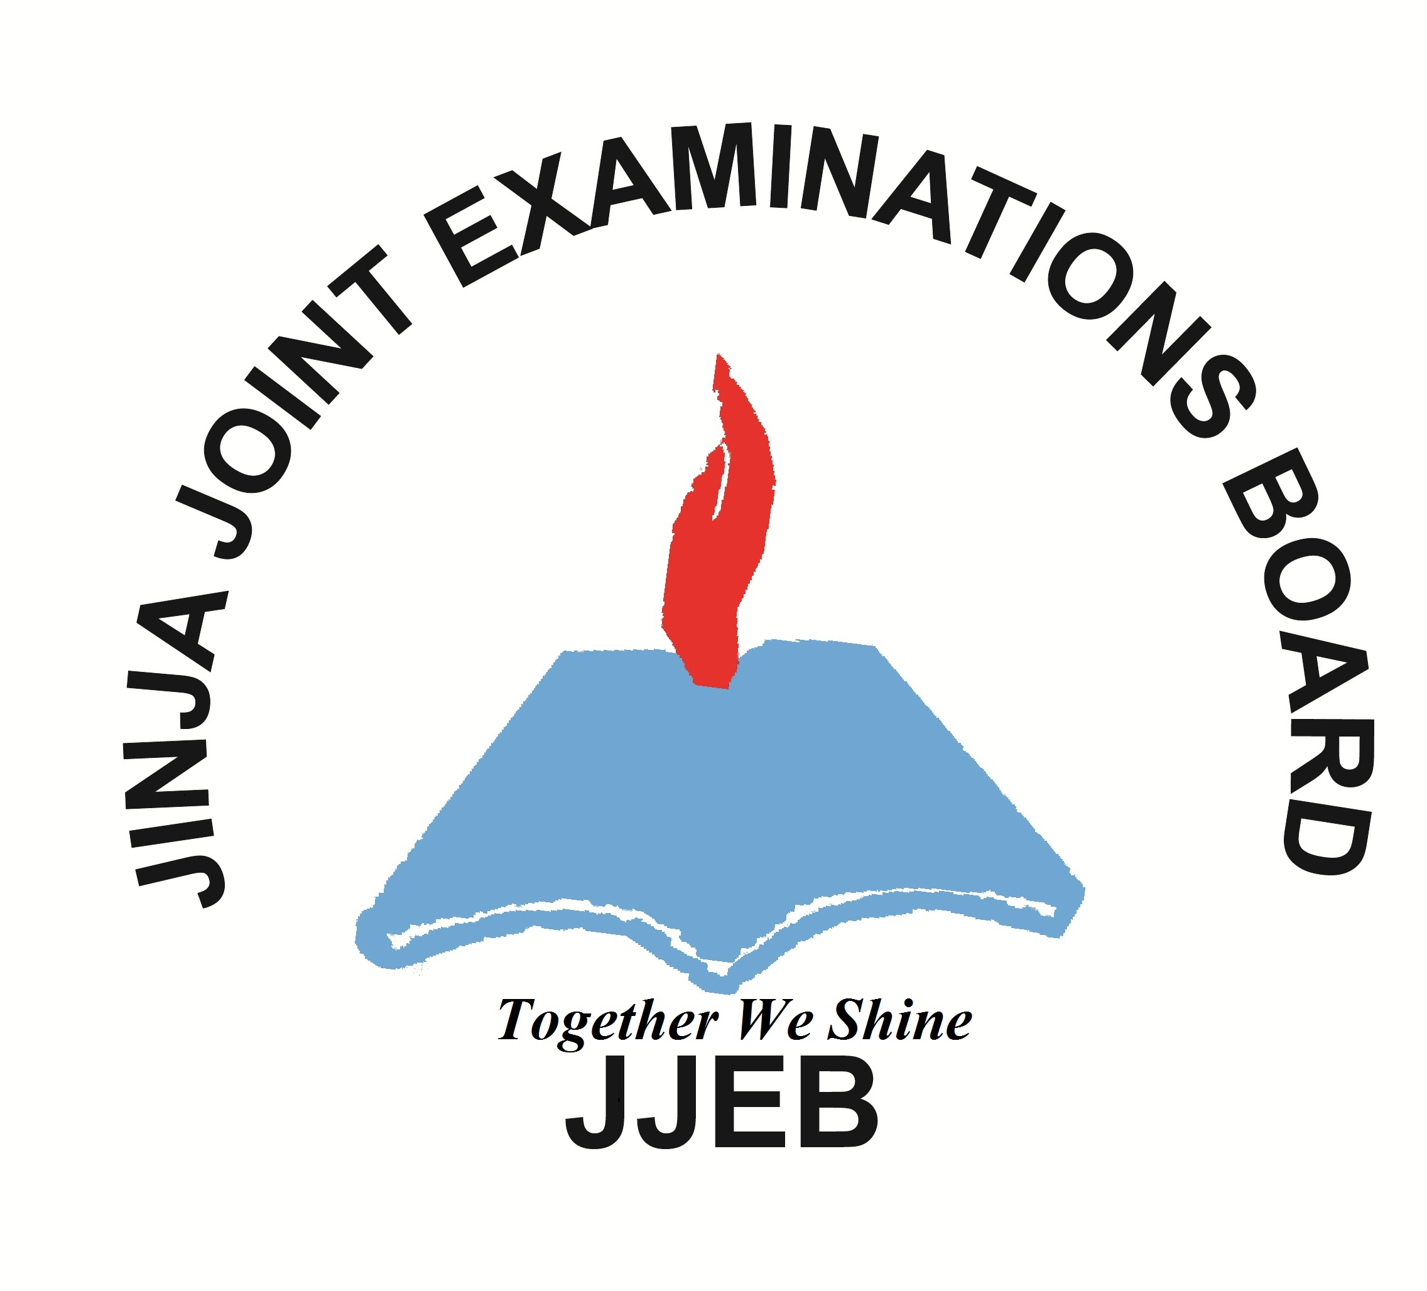
CONFIDENTIAL
P525/3/Inst. Sc.
CHEMISTRY
PRACTICAL
INSTRUCTIONS
Paper 3
AUGUST, 2017

JINJA JOINT EXAMINATIONS BOARD

Uganda Advanced Certificate of Education

MOCK EXAMINATIONS –AUGUST, 2017

CHEMISTRY

PRACTICAL

INSTRUCTIONS

Paper 3

CONFIDENTIAL:

GREAT CARE SHOULD BE TAKEN THAT THE INFORMATION GIVEN BELOW
DOES NOT REACH THE CANDIDATES EITHER DIRECTLY OR INDIRECTLY.

- The description of the reagents and chemicals specified below does not necessarily correspond with the description in the question paper. Candidates must NOT be informed of the difference.

- Candidates are not allowed to use reference books (i.e. textbooks, booklets on qualitative analysis etc) during the examination.

- In addition to the ordinarily fittings and apparatus contained in a Chemistry laboratory, each candidates will require:

Each student should be provided with

- 1 burette (50 cm³)
- 1 pipette (25 or 20cm³)
- 150cm³ FA1
- 100cm³FA2
- 7g of E
- 80cm³ of 10% Potassium iodide solution
- 200cm³ of 1M sulphuric acid
- 2 Conical flasks
- 250cm³ volumetric flask

Easy access to:
- Starch indicator
- Copper(I) iodide suspension

FA1 is made by dissolving 25.8g of sodium thiosulphate – 5 – water in water to make 1 dm3 of solution

FA2 is made by dissolving 3.5g of potassium iodate in water to make 1dm3 of solution.
Copper(I) iodide suspension is made by mixing equal volumes of 0.5M Copper(II) sulphate and 10% potassium iodide solutions, and the add sodium thiosulphate until the brown colour of iodine just disappears.

